Dis-Eur-Spain-Slate plaque-ca 3,500–2,750 BCE-Badajoz, Spain

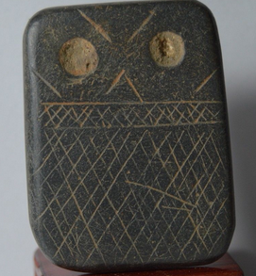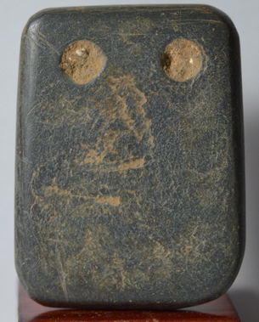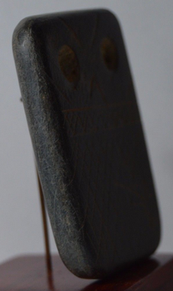

**Formal Label:** Spain, Late Neolithic slate plaque ca. 3,500–2,750 BCE

**Accession Number:**

**Date or Time Horizon:** **3500-2750 BCE**

**Geographical Area:** Badajoz, SW Spain

**Cultural Affiliation:** Late Neolithic

**Medium:** Slate

**Dimensions:**

**Weight:**

**Provenance:** Belgian Collection acquired 1980´s, then **David Vosez Garcia, Francia no. 20, cp 28916, Lecones, Madrid, Spain**.

**Condition: No defects.**

**Discussion:**

This Late Neolithic engraved slate plaque ca. 3,500–2,750 BCE (calibrated age) (O’Brien 2014) probably from the area of Badajoz, Spain (southwest Iberian Peninsula) (**David Vosez Garcia,** pers. comm.; see Almagro Gorbea, 1973). It is similar to one plaque published by Hibbs (1994: 30, fig. 4). The plaque has three registers: a lower register of six levels of cross-hatcheurs, a middle register set off by two horizontal lines of two levels of cross-hatcheurs and an upper register of “eye” designs with a drilled hole through which ties were passed (based on use-wear analysis) so that it was probably worn as an amulet around the neck. These eye designs are suggested to be those of the barn owl (*Tyto alba*) by Lillios (2008: 125), which coincides with the owl-like geometry of the lines surrounding the eyes. While each of the six to ten “styles” of the slate plaques is distinctive in its specific details, each “style” exhibits a consistency in a basic design grammar (Lillios 2008). However, the style of this particular plaque according to the schema offered by Lillios exhibits a “Style variant” in which the engraving is very sketchy and does not appear to produce any recognizable grammar, perhaps the result of a child’s attempt or that of an apprentice according to Lillios (2008: 72). I might suggest, however, that this “non-style” motif might represent early attempts at formulating a grammar of design before a satisfactory one was achieved, and, therefore, it would have preceded rather than followed most of the rest.

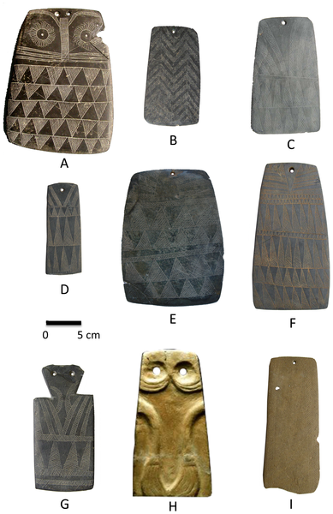

**Figure 1. Engraved plaques from the Iberian Peninsula.**  
a, Valencina de la Concepción, Sevilla, Spain (Museo Arqueológico de Sevilla [MAS]); b, S. Geraldo, Montemor-o-Novo, Évora, Portugal (Museo Nacional de Arqueologia de Portugal [MNAP]); c, Monsaraz, Reguengos de Monsaraz, Évora (MNAP); d, Mora, Évora (MNAP); e, Jabugo, Aracena, Huelva, Spain (MAS); f, Ciborro, Monte-o-Novo, Évora (MNAP); g, Marvão, Portalegre, Portugal (MNAP); h, Estremoz, Évora (MNAP); and I, Pavia, Mora, Évora (MNAP).From: http://www.plosone.org/article/fetchObject.action?uri=info:doi/10.1371/journal.pone.0088296.g001&representation=PNG_M

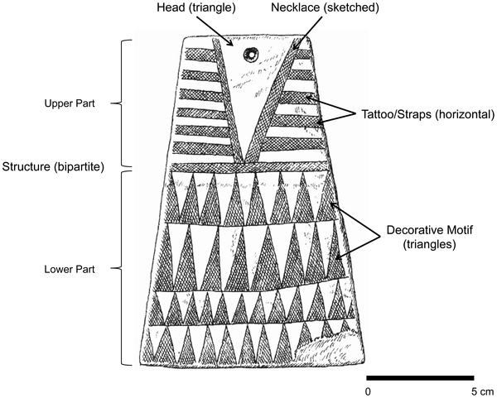

**Fig. 2** -  General design of the plaques.From: http://www.plosone.org/article/fetchObject.action?uri=info:doi/10.1371/journal.pone.0088296.g002&representation=PNG_M

The Late Neolithic Iberian emergence of expanded craft specialization (Åberg 1921), of which these engraved plaques are an example, reflects a shift in growing cultural stability. Various groups began to coalesce around social and familial identities that expressed, in visual symbols, grammars of design in pictographs (Breuil 1935; Correia 1917; Veiga 1887) and these engraved plaques (Frankowski 1920; Lisboa, 1985; Rodrigues 1986). The social shift underlying these design grammars represents a coalescence of group identities into fewer common cultural nodes than had existed in the Chalcolithic (Bueno Ramírez 1992; Correia 1921). As a result, Isabel Lisboa and Katina Lillios, interpreted these slate plaques as heraldic or genealogical records that were designed to standardize the symbolic identity of familial or social groups (Lisboa, 1985; Lillios, 2002, 2003, 2008). However, Daniel García Rivero and Michael J. O’Brien (2014) have found “that this is not the case, even when the most supportive data and techniques are used. Rather, we suspect there was a common ideological background to the use of plaques that overlay the southwestern Iberian Peninsula, with little or no geographic patterning. This would entail a cultural system in which plaque design was based on a fundamental core idea, with a number of mutable and variable elements surrounding it.” Perhaps, one aspect of this common ideological background is the way these plaques were buried with the deceased. In a recent study using an array of high-tech measuring tools, gold, silver and copper dust was found on the surface of archaeologically excavated plaques from megalithic contexts, representing not only the first discover of the use of these minerals in a conformed megalithic context but also the first confirmed use of these dusts anywhere in internments in Europe (Posedi et al 2015). Unfortunately, the present plaque was “cleaned” of encrustations prior to its being acquired by me so that when some of these techniques were run on it no trace of any metallic dust was observed.

**References**

Åberg, N. 1921. *Civilisation énéolithique dans la Penínsule Ibérique*. Uppsala, A.-b. Akademiska bokhandeln i kommission.

Almagro Gorbea, M. J. 1973. *Los Idolos del Bronce I Hispano*. Madrid, Consejo Superior de Investigaciones Científicas.

Ameghino, F. 1879. "L'homme préhistorique dans La Plata." *Revue d'Anthropologie* **2**: 210-249.

Breuil, H. 1935. *Les peintures rupestres schématiques de la Penínsule Ibérique*. Paris.

Bueno Ramírez, P. 1992. "Les plaques décorées alentéjaines: approche de leur étude et analyse." *L’Anthropologie* **96**(2-3): 573-604.

Carpenter, E., Ed. 1986-1988. *Materials for the study of social symbolism in ancient & tribal art : a record of tradition & continuity/ based on the researches & writings of Carl Schuster*. New York: Rock Foundation.

Correia, V. 1917. “Arte pré-histórico: os idolos-placas,” *Terra Portuguesa*, **12**: 29-35.

Correia, V. 1921. *El Neolítico de Pavía*. Madrid, Museo Nacional de Ciencias Naturales.

Frankowski, E. 1920. *Estelas Discoideas de la Península Ibérica*. Madrid, Museo Nacional de Ciencias Naturales.

Garcı´a Rivero, D., M. J. O’Brien. 2014. “Phylogenetic Analysis Shows That Neolithic Slate Plaques from the Southwestern Iberian Peninsula Are Not

Genealogical Recording Systems,” *PLoS ONE* 9(2): e88296. doi:10.1371/journal.pone.0088296

Hibbs, Vivian A.1994. *Iberian Antiquities from the Collection of Leon Levy and Shelby White: September 14-December 10, 1993*. Seattle: University of Washington Press

Lillios, Katina T. 2002. "Some new views of the engraved slate plaques of southwest Iberia*.*" *Revista Portuguesa de Arqueologia* **5**(2): 135-151.

Lillios, Katina T. 2003. “Creating memory in prehistory: the engraved slate plaques of southwest Iberia.” In R. Van Dyke and S. Alcock, eds. *Archaeologies of Memory*. Oxford: Blackwell**,** pp.129-150.

# Lillios, Katina T. 2008. *Heraldry for the Dead: Memory, Identity, and the Engraved Stone Plaques of Neolithic Iberia*. University of Texas Press.

# Lisboa, Isabel. 1985. “Meaning and Messages: Mapping style in the Iberian Chalcolithic,” *Cambridge Archaeological Review* 4:2, 181-196.

Posedi, I, L. Dias, S. Costa, P. Barrulas J. Mirão. 2015. Archaeometrical analysis of the slate plaques (placas de xisto) from dolmens of Alentejo region, Portugal: new possible insights on funerary practices using gold, silver, copper, cinnabar and red ochre dust. XI CONGRESSO IBÉRICO DE ARQUEOMETRIA, 14 - 16 Oct., Universidade de Évora, Laboratório HERCULES Rodrigues, M. da C. M. 1986. *Código Para a Análise das Placas de Xisto Gravadas do Alto Alentejo*. Castelo de Vide: Câmara Municipal de Castelo de Vide.

Rodrigues, M. da C. M. 1986. *Estudo Ideológico-Simbólico das Placas de Xisto Gravadas*. Castelo de Vide, Câmara Municipal de Castelo de Vide.

Vasconcellos, J. L. de and Sociedade de Geografia de Lisboa. 1897. *Religiões da Lusitania na parte que principalmente se refere a Portugal*. Lisboa, Imprensa Nacional.

Veiga, S. P. M. E. da. 1887. *Antiguidades monumentaes do Algarve: tempos prehistoricos*. Lisboa, Imprensa nacional.